**Package**

1] Creating a package to calculate the gross pay, taxes and net pay amounts for a given employee

INSERT INTO employee_payroll VALUES ('SW1011', TO_DATE('2023-01-01', 'YYYY-MM-DD'), TIMESTAMP '2023-01-02 08:00:00', TIMESTAMP '2023-01-02 17:00:00', 10.00, 1);

CREATE OR REPLACE PACKAGE Employee_Salary_Package AS

PROCEDURE calculate_gross_salary(p_emp_id IN INT, p_gross_salary OUT NUMBER);

FUNCTION calculate_total_taxes(p_gross_salary IN NUMBER) RETURN NUMBER;

FUNCTION calculate_net_salary(p_gross_salary IN NUMBER, p_taxes IN NUMBER) RETURN NUMBER;

END Employee_Salary_Package;

/

CREATE OR REPLACE PACKAGE BODY Employee_Salary_Package AS

PROCEDURE calculate_gross_salary(p_emp_id IN INT, p_gross_salary OUT NUMBER) AS

v_gross_salary NUMBER := 0;

v_swipe_total NUMBER;

v_swipe_id VARCHAR2(100);

BEGIN

FOR swipe_record IN (SELECT swipe_id FROM employee_payroll WHERE emp_id = p_emp_id) LOOP

v_swipe_id := swipe_record.swipe_id;

SELECT (EXTRACT(HOUR FROM (check_out_time - check_in_time)) +

EXTRACT(MINUTE FROM (check_out_time - check_in_time)) / 60) * hourly_pay

INTO v_swipe_total

FROM employee_payroll

WHERE swipe_id = v_swipe_id;

v_gross_salary := v_gross_salary + v_swipe_total;

END LOOP;

p_gross_salary := v_gross_salary;

END calculate_gross_salary;

FUNCTION calculate_total_taxes(p_gross_salary IN NUMBER) RETURN NUMBER AS

v_total_taxes NUMBER := 0;

BEGIN

IF p_gross_salary > 100 THEN

v_total_taxes := p_gross_salary * 0.1; -- 10% tax

END IF;

RETURN v_total_taxes;

END calculate_total_taxes;

FUNCTION calculate_net_salary(p_gross_salary IN NUMBER, p_taxes IN NUMBER) RETURN NUMBER AS

v_net_salary NUMBER;

BEGIN

v_net_salary := p_gross_salary - p_taxes;

RETURN v_net_salary;

END calculate_net_salary;

END Employee_Salary_Package;

/

DECLARE

p_emp_id INT := 1;

v_gross_salary NUMBER;

v_total_taxes NUMBER;

v_net_salary NUMBER;

BEGIN

Employee_Salary_Package.calculate_gross_salary(p_emp_id, v_gross_salary);

v_total_taxes := Employee_Salary_Package.calculate_total_taxes(v_gross_salary);

v_net_salary := Employee_Salary_Package.calculate_net_salary(v_gross_salary, v_total_taxes);

DBMS_OUTPUT.PUT_LINE('Pay check details for Employee ID ' || p_emp_id || ':');

DBMS_OUTPUT.PUT_LINE('Gross salary: ' || TO_CHAR(v_gross_salary, '99999.99'));

DBMS_OUTPUT.PUT_LINE('Total taxes: ' || TO_CHAR(v_total_taxes, '99999.99'));

DBMS_OUTPUT.PUT_LINE('Net salary: ' || TO_CHAR(v_net_salary, '99999.99'));

END;

/

**Procedures**

**1]** Creating a procedure to update the food quantity for animals with up to date vaccination status

CREATE OR REPLACE PROCEDURE update_food_quantity(changed_quantity INT) AS

BEGIN

FOR rec IN (

SELECT a.animal_id, n.food_id, n.food_quantity, a.a_vaccine_status

FROM animal_info a

JOIN need ON a.animal_id = need.animal_id

JOIN nutrition n ON need.food_id = n.food_id

)

LOOP

IF rec.a_vaccine_status = 'Up to date' THEN

UPDATE nutrition

SET food_quantity = food_quantity - changed_quantity

WHERE food_id = rec.food_id;

DBMS_OUTPUT.PUT_LINE('Food quantity updated for animal ' || rec.animal_id || ': ' || (rec.food_quantity - changed_quantity));

END IF;

END LOOP;

END;

/

BEGIN

update_food_quantity(2); -- Call the procedure with the desired value for changed_quantity

END;

/

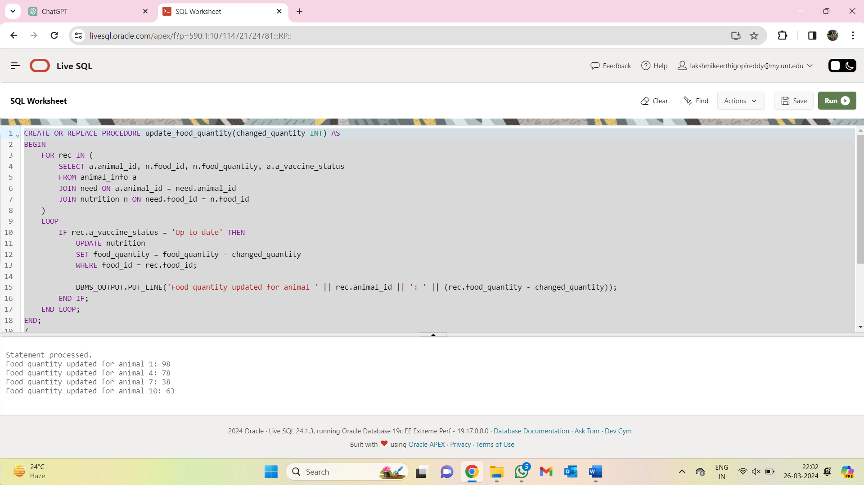

**2]** Creating a procedure to get the details of Veterinarians with more than x years of work experience

CREATE OR REPLACE PROCEDURE GetVeterinariansByExperience(

p_min_experience IN INT,

p_cursor OUT SYS_REFCURSOR

) AS

BEGIN

-- Open a cursor to retrieve veterinarians with experience greater than or equal to the provided minimum experience

OPEN p_cursor FOR

SELECT *

FROM veterinary

WHERE work_exp >= p_min_experience;

END GetVeterinariansByExperience;

/

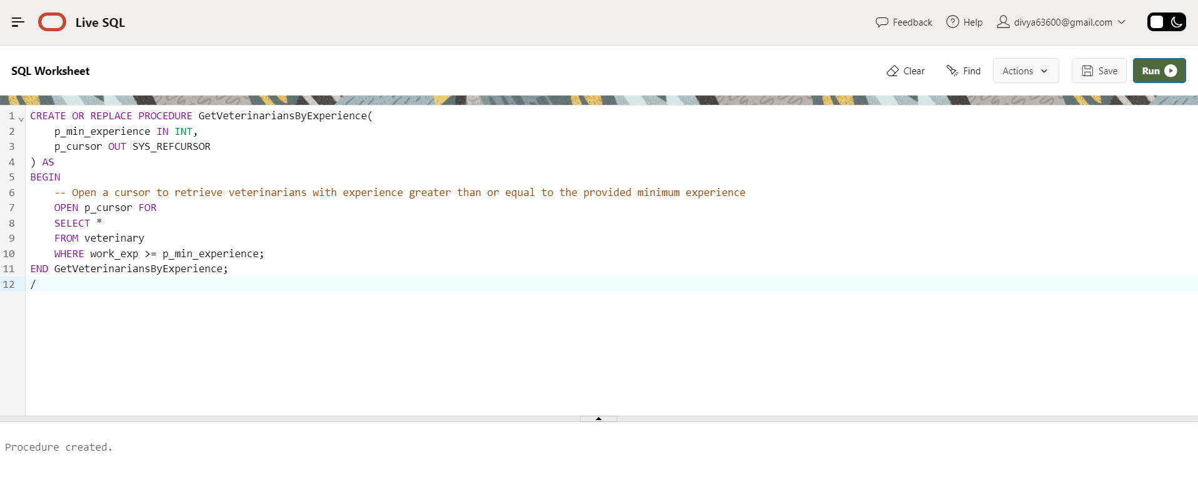

DECLARE

vet_cursor SYS_REFCURSOR;

v_vet_id veterinary.vet_id%TYPE;

v_vet_name veterinary.vet_name%TYPE;

v_vet_contact veterinary.vet_contact%TYPE;

v_education veterinary.education%TYPE;

v_work_exp veterinary.work_exp%TYPE;

BEGIN

-- Call the procedure to retrieve veterinarians with at least 10 years of experience

GetVeterinariansByExperience(10, vet_cursor);

-- Fetch and display the results

LOOP

FETCH vet_cursor INTO v_vet_id, v_vet_name, v_vet_contact, v_education, v_work_exp;

EXIT WHEN vet_cursor%NOTFOUND;

DBMS_OUTPUT.PUT_LINE('Veterinarian ID: ' || v_vet_id || ', Name: ' || v_vet_name || ', Contact: ' || v_vet_contact || ', Education: ' || v_education || ', Experience: ' || v_work_exp);

END LOOP;

CLOSE vet_cursor;

END;

/

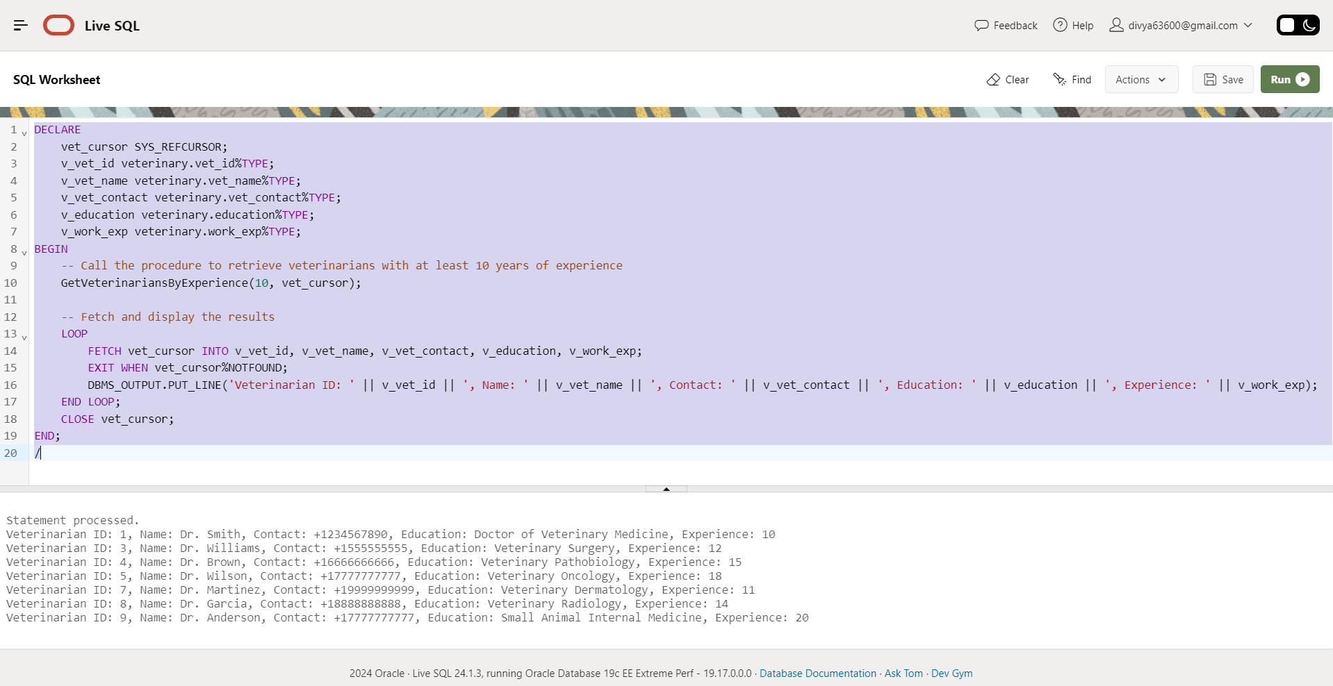

3] Creating a procedure to display the vaccinations given on a particular date

CREATE OR REPLACE PROCEDURE DisplayVaccinationsForDate(

p_vaccination_date IN DATE

) AS

BEGIN

-- Display vaccinations for the given date

FOR rec IN (

SELECT vaccination_name, vaccination_date, vaccination_dosage

FROM vaccination

WHERE vaccination_date = p_vaccination_date

) LOOP

DBMS_OUTPUT.PUT_LINE('Vaccination Name: ' || rec.vaccination_name);

DBMS_OUTPUT.PUT_LINE('Vaccination Date: ' || TO_CHAR(rec.vaccination_date, 'YYYY-MM-DD'));

DBMS_OUTPUT.PUT_LINE('Vaccination Dosage: ' || rec.vaccination_dosage);

DBMS_OUTPUT.PUT_LINE('---------------------');

END LOOP;

END DisplayVaccinationsForDate;

/

DECLARE

-- Call the procedure to display vaccinations for a given date

v_date DATE := DATE '2023-05-12'; -- Example date

BEGIN

DisplayVaccinationsForDate(v_date);

END;

/

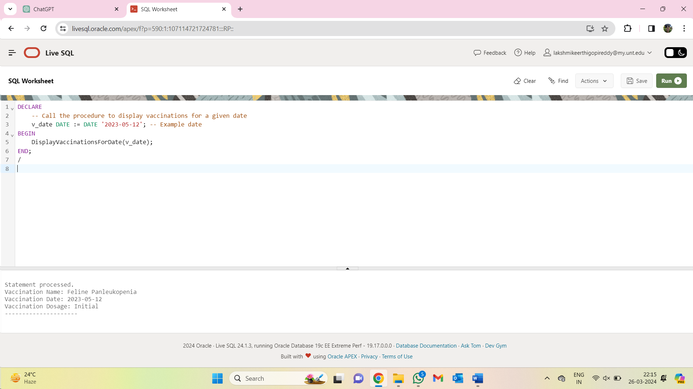

4] Creating a procedure to get the vaccination name for a particular disease as per historical records.

CREATE OR REPLACE PROCEDURE GetVaccinationForDisease(

p_disease IN VARCHAR2,

p_vaccination_name OUT VARCHAR2

) AS

BEGIN

-- Retrieve vaccination name based on the provided disease

SELECT v.vaccination_name

INTO p_vaccination_name

FROM vaccination v

JOIN medical_history m ON v.vaccination_id = m.vaccination_id

WHERE m.disease = p_disease;

EXCEPTION

WHEN NO_DATA_FOUND THEN

-- Handle case where no vaccination is found for the provided disease

DBMS_OUTPUT.PUT_LINE('No vaccination found for the provided disease.');

END GetVaccinationForDisease;

/

DECLARE

v_vaccination_name vaccination.vaccination_name%TYPE;

v_disease VARCHAR2(25) := ‘Infection’; -- Provide the disease name here

BEGIN

-- Call the procedure to retrieve vaccination name for the given disease

GetVaccinationForDisease(v_disease, v_vaccination_name);

-- Display the retrieved vaccination name

DBMS_OUTPUT.PUT_LINE('Vaccination Name for ' || v_disease || ': ' || v_vaccination_name);

END;

/

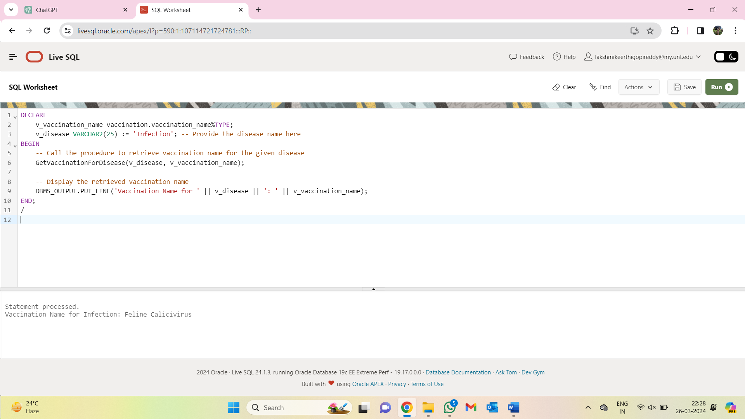

5] Creating a procedure to get the list of all the shelters with capacity more than the given number

CREATE OR REPLACE PROCEDURE GetSheltersWithCapacity(

p_capacity_threshold IN INT

) AS

BEGIN

-- Retrieve shelter names for shelters with capacity greater than the input value

FOR shelter_rec IN (

SELECT sb.shelter_name

FROM shelter_branch sb

JOIN facilities f ON sb.shelter_id = f.shelter_id

WHERE f.f_capacity > p_capacity_threshold

) LOOP

-- Display shelter names

DBMS_OUTPUT.PUT_LINE('Shelter Name: ' || shelter_rec.shelter_name);

END LOOP;

END GetSheltersWithCapacity;

/

DECLARE

v_capacity_threshold INT := 50; -- Provide the capacity threshold here

BEGIN

-- Call the procedure to retrieve shelter names with capacity greater than the threshold

GetSheltersWithCapacity(v_capacity_threshold);

END;

/

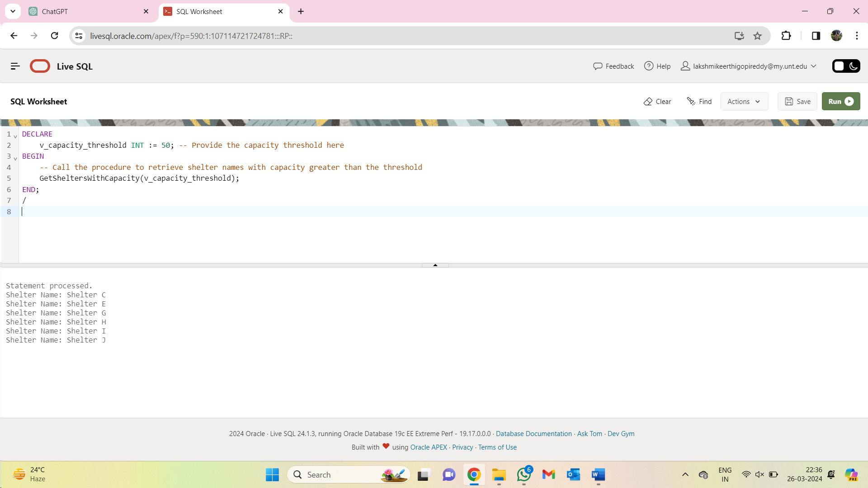

**Functions:**

1] Creating a function to get the count of the number of times an animal is transferred from one shelter to another.

CREATE OR REPLACE FUNCTION GetTransferCount(

p_animal_id INT

) RETURN INT AS

v_transfer_count INT;

BEGIN

-- Retrieve the number of transfers for the provided animal ID

SELECT COUNT(*)

INTO v_transfer_count

FROM animal_transfer_records

WHERE animal_id = p_animal_id;

-- Return the transfer count

RETURN v_transfer_count;

EXCEPTION

WHEN NO_DATA_FOUND THEN

RETURN 0; -- Return 0 if no transfer record is found

END GetTransferCount;

/

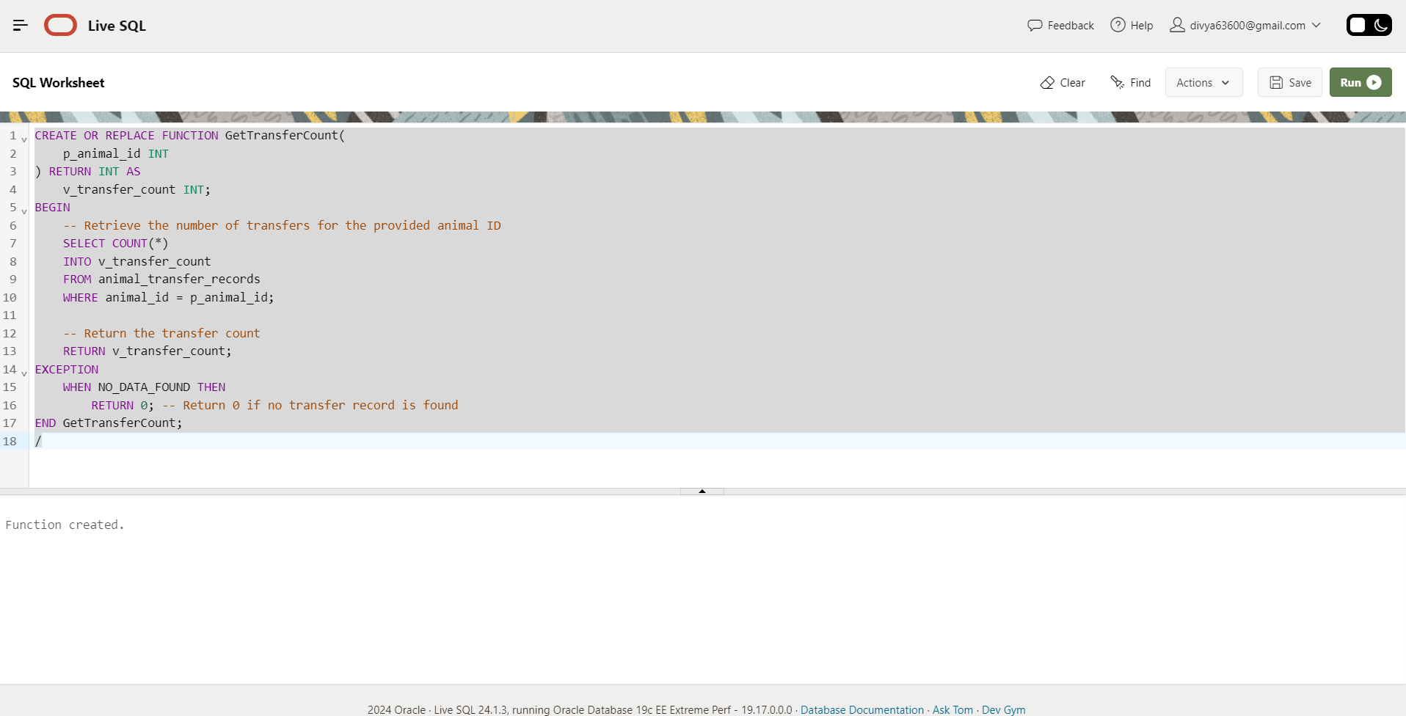

SELECT GetTransferCount(3) AS transfer_count FROM dual;

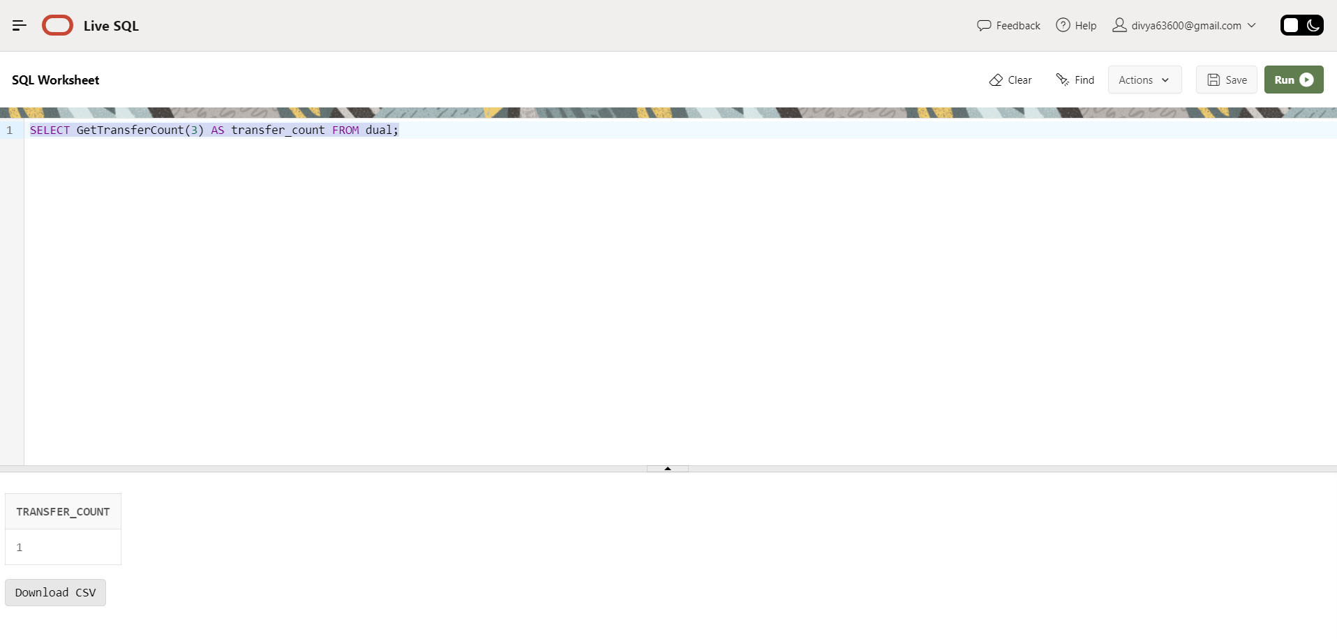

2] Creating a function to get the salary of a given employee

CREATE OR REPLACE FUNCTION GetEmployeeSalary(

p_emp_id INT

) RETURN NUMERIC AS

v_salary NUMERIC;

BEGIN

-- Retrieve the salary of the employee with the provided ID

SELECT emp_salary

INTO v_salary

FROM employees_staff_details

WHERE emp_id = p_emp_id;

-- Return the salary

RETURN v_salary;

EXCEPTION

WHEN NO_DATA_FOUND THEN

RETURN NULL; -- Return NULL if no employee with the provided ID is found

END GetEmployeeSalary;

/

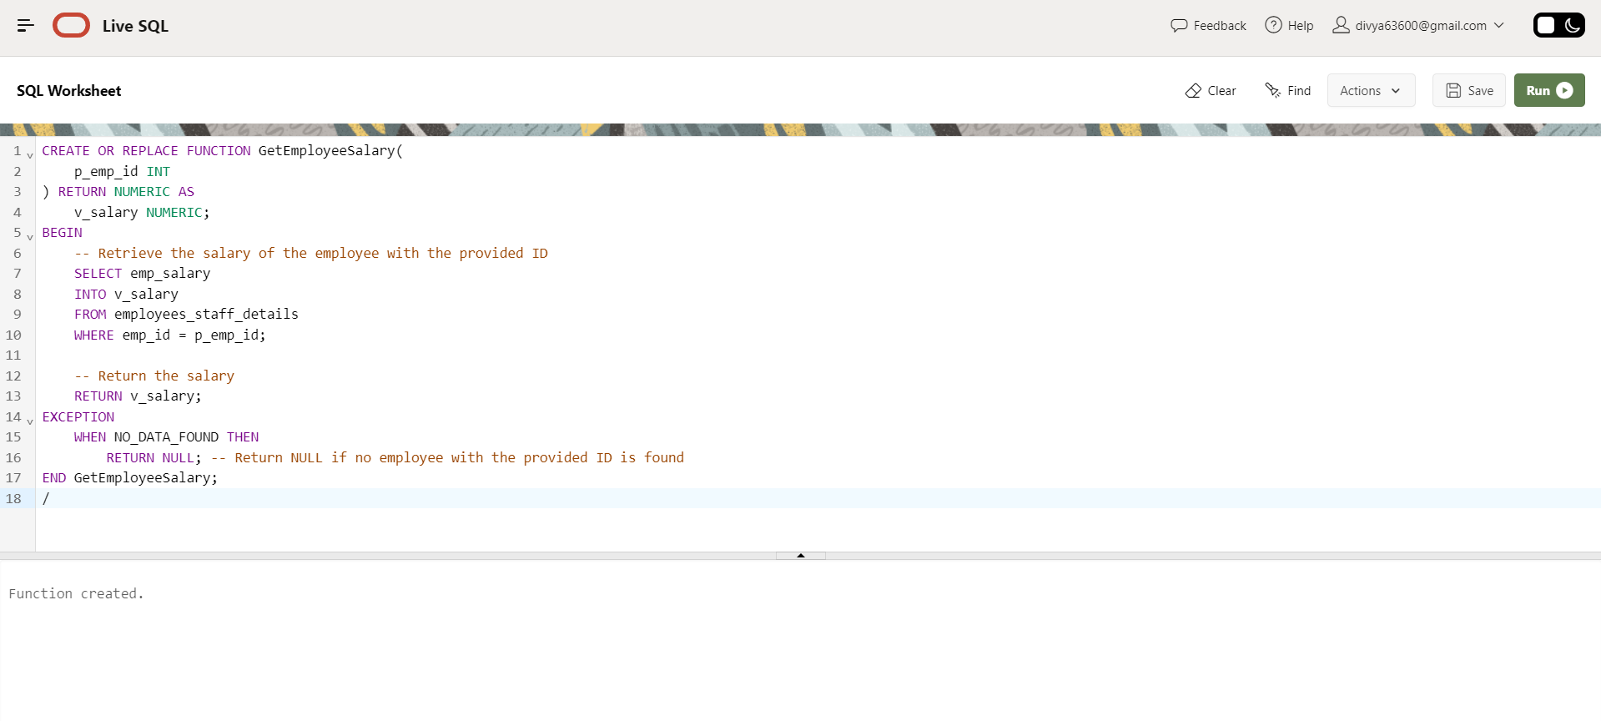

SELECT GetEmployeeSalary(3) AS salary FROM dual;

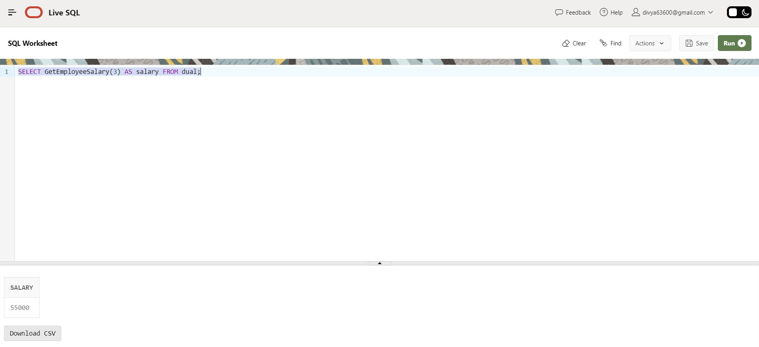

3] Creating a function to check where outdoor space is available for a given shelter ID

CREATE OR REPLACE FUNCTION IsOutdoorAvailable(p_shelter_id IN INT) RETURN VARCHAR2 AS

outdoor_status VARCHAR2(3);

BEGIN

SELECT CASE WHEN outdoor_space = 'Y' THEN 'Yes' ELSE 'No' END

INTO outdoor_status

FROM facilities

WHERE shelter_id = p_shelter_id;

RETURN outdoor_status;

END;

DECLARE

v_outdoor_status VARCHAR2(3);

v_shelter_id INT := 2; -- Provide the shelter ID for which you want to check outdoor availability

BEGIN

-- Call the function and retrieve the outdoor status

v_outdoor_status := IsOutdoorAvailable(v_shelter_id);

-- Display the result

IF v_outdoor_status = 'Yes' THEN

DBMS_OUTPUT.PUT_LINE('Outdoor space is available.');

ELSE

DBMS_OUTPUT.PUT_LINE('Outdoor space is not available.');

END IF;

END;

/

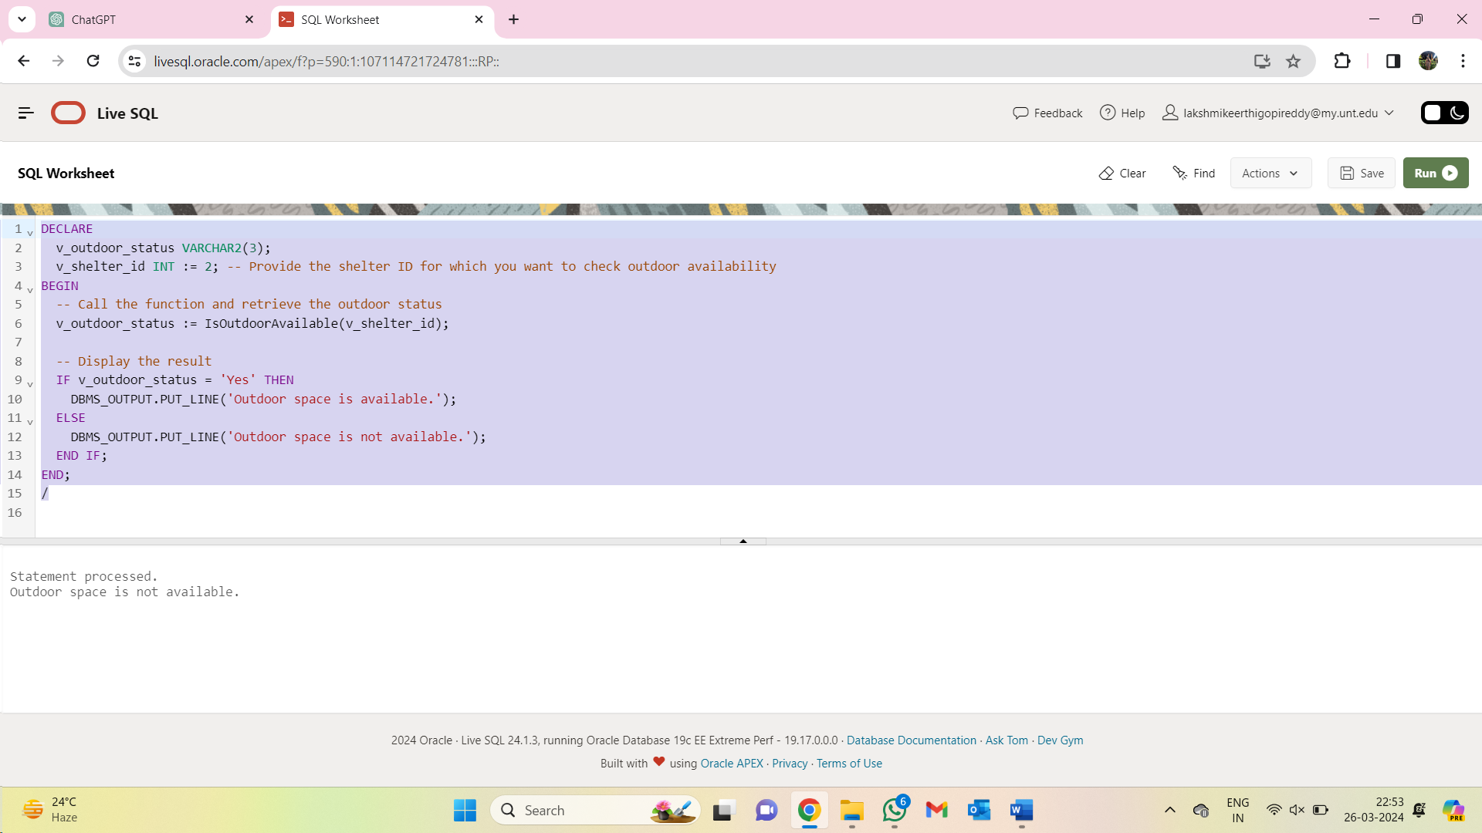

4] Creating a function to check whether a new animal can be inserted into a shelter considering its capacity according to the facilities.

CREATE OR REPLACE FUNCTION IsSpaceAvailable(p_shelter_id IN INT) RETURN VARCHAR2 AS

v_capacity INT;

v_ani_count INT;

BEGIN

-- Retrieve the capacity of the shelter's facility

SELECT f_capacity

INTO v_capacity

FROM facilities

WHERE shelter_id = p_shelter_id;

-- Retrieve the current animal count for the specified shelter

SELECT COUNT(DISTINCT animal_id)

INTO v_ani_count

FROM accommodate

WHERE shelter_id = p_shelter_id;

-- Check if there is space available based on current animal count and facility capacity

IF v_ani_count < v_capacity THEN

RETURN 'Space Available';

ELSE

RETURN 'No Space Available';

END IF;

EXCEPTION

WHEN NO_DATA_FOUND THEN

RETURN 'Shelter Not Found';

END;

DECLARE

v_shelter_id INT := 2; -- Provide the shelter ID you want to check

v_space_status VARCHAR2(20);

BEGIN

-- Call the function to check space availability

v_space_status := IsSpaceAvailable(v_shelter_id);

-- Display the result

DBMS_OUTPUT.PUT_LINE('Space Status for Shelter ' || v_shelter_id || ': ' || v_space_status);

END;

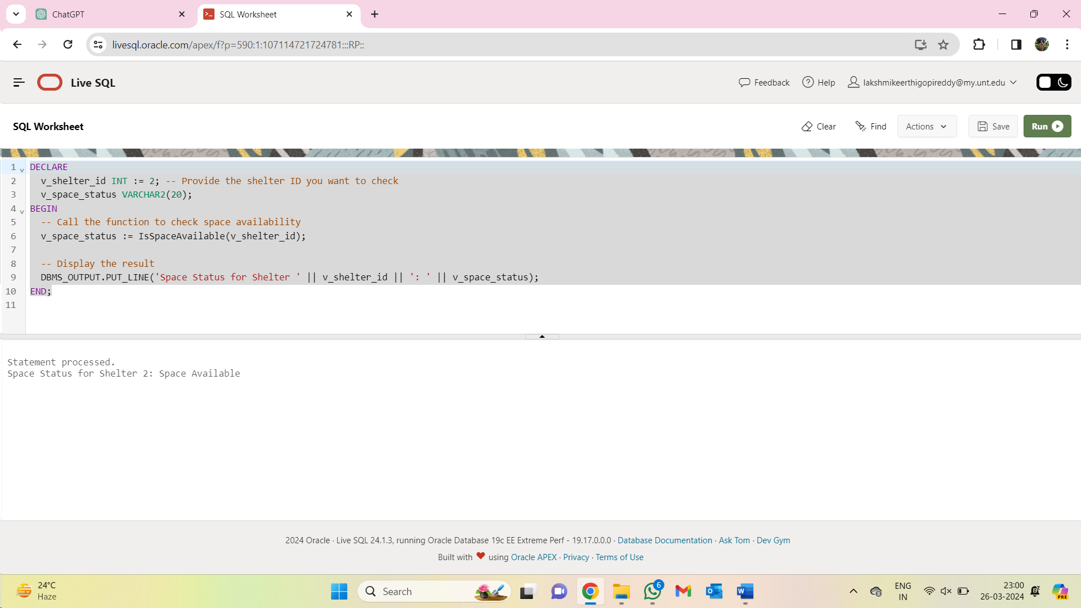

5] Creating a function to get the total funds from the sponsors for a particular shelter ID.

CREATE OR REPLACE FUNCTION GetFundsForShelter(

p_shelter_id IN INT

) RETURN NUMERIC AS

total_funds NUMERIC := 0;

BEGIN

-- Calculate the total funds received by the shelter from all sponsors

SELECT SUM(amount) INTO total_funds

FROM payment_details

WHERE sponsor_id IN (

SELECT sponsor_id

FROM support

WHERE shelter_id = p_shelter_id

);

RETURN total_funds;

END;

/

DECLARE

v_shelter_id INT := 1; -- Provide the shelter ID for which you want to retrieve funds

v_total_funds NUMERIC;

BEGIN

-- Call the function to get total funds for the specified shelter

v_total_funds := GetFundsForShelter(v_shelter_id);

-- Display the total funds

DBMS_OUTPUT.PUT_LINE('Total funds for shelter ' || v_shelter_id || ': ' || v_total_funds);

END;

/

**Triggers**

1] Creating a trigger to calculate the adoption fee post discount (10% if 1000 or above, 5% if 750 or above) and update the value in table accordingly.

CREATE OR REPLACE TRIGGER CalculateDiscount

AFTER INSERT ON adoption_details

FOR EACH ROW

DECLARE

v_payment_amount adoption_details.ad_fee%TYPE;

BEGIN

-- Retrieve the payment amount for the new adoption

v_payment_amount := :NEW.ad_fee;

-- Check if the payment amount is eligible for a discount

IF v_payment_amount >= 1000 THEN

-- Apply a 10% discount for payments of 1000 or more

:NEW.ad_fee := v_payment_amount * 0.9;

ELSIF v_payment_amount >= 750 THEN

-- Apply a 5% discount for payments between 750 and 999

:NEW.ad_fee := v_payment_amount * 0.95;

END IF;

END;

/

INSERT INTO adoption_details (ad_ID, ad_name, ad_contact, ad_date, ad_fee)

VALUES (199, 'JNeww', '1234567890', SYSDATE, 1000);

select * from adoption_details where ad_ID = 199;

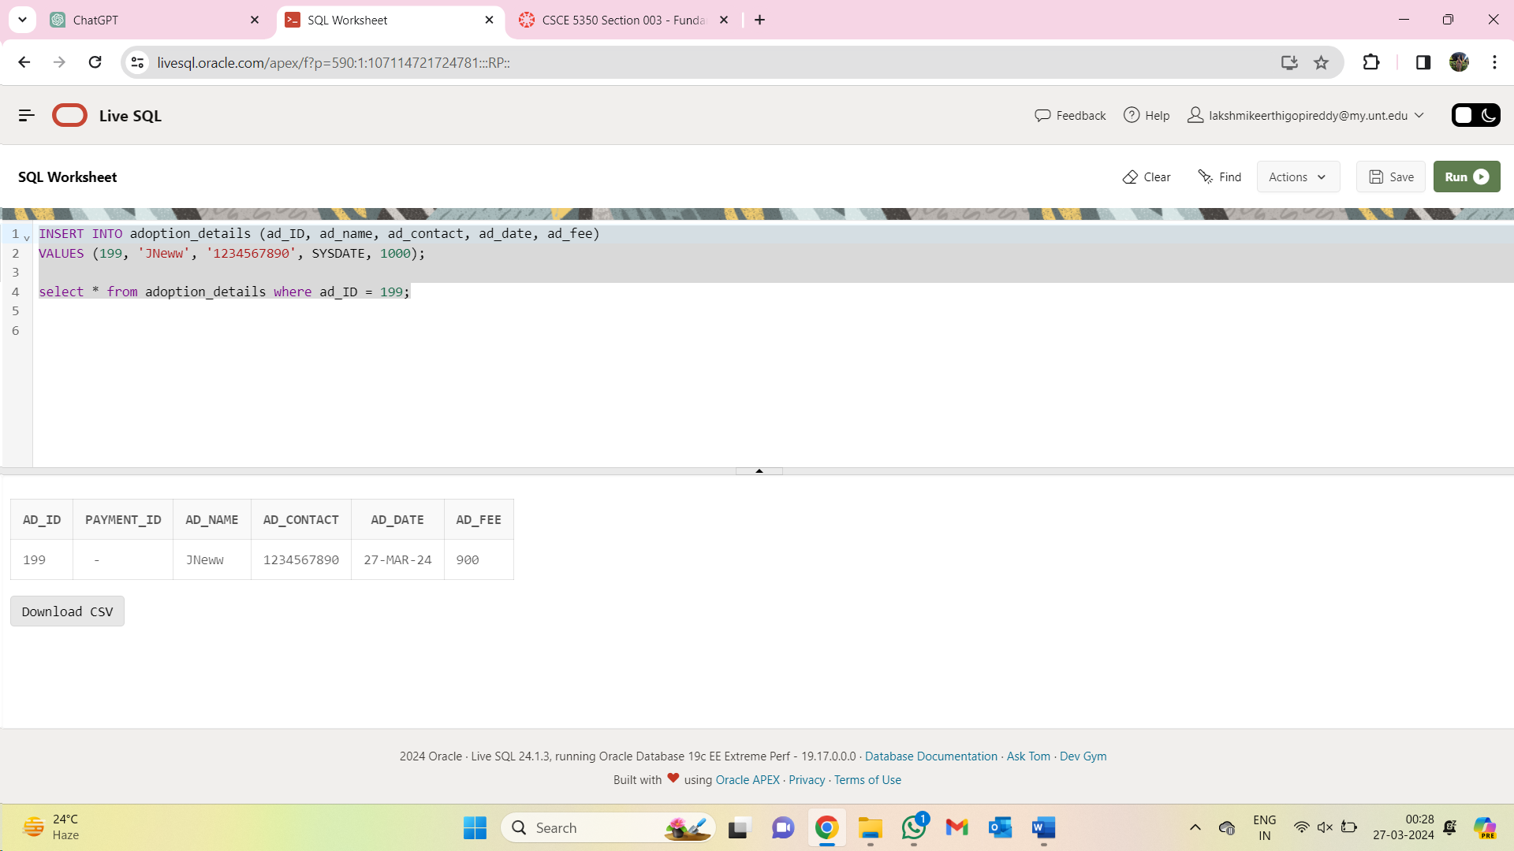

2] Creating a trigger to ensure that the reason for surrendering an animal does not exceed more than 20 characters.

CREATE OR REPLACE TRIGGER CheckSurrenderReason

BEFORE INSERT OR UPDATE ON surrender_details

FOR EACH ROW

DECLARE

v_reason_length INT;

BEGIN

-- Check the length of the surrender reason

v_reason_length := LENGTH(:NEW.s_reason);

-- Enforce a maximum length for the surrender reason

IF v_reason_length > 20 THEN

-- If the reason length exceeds the limit, raise an error

RAISE_APPLICATION_ERROR(-20001, 'Surrender reason cannot exceed 20 characters.');

END IF;

END;

/

INSERT INTO surrender_details (s_id, s_date, s_name, s_reason)

VALUES (1011, SYSDATE, 'John Doe', 'The reason for surrendering the pet is due to unforeseen circumstances beyond my control, including financial constraints, health issues, and changes in living arrangements');

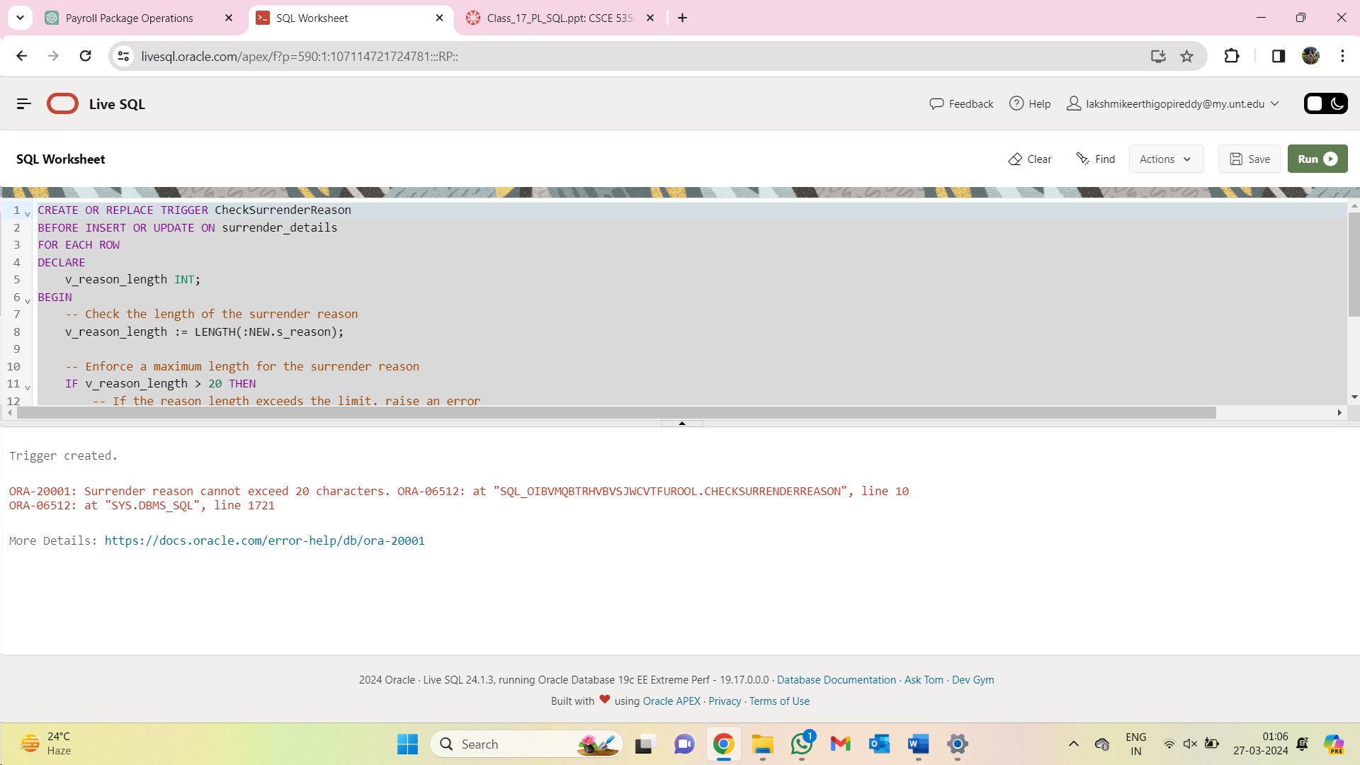

3] Creating a trigger to ensure that the date of acquisition of an animal is always after the date of birth of the animal.

CREATE OR REPLACE TRIGGER CheckDOB

BEFORE INSERT ON animal_info

FOR EACH ROW

BEGIN

IF :NEW.a_dob > :NEW.date_of_acquisition THEN

RAISE_APPLICATION_ERROR(-20001, 'Date of birth cannot be greater than date of acquisition.');

END IF;

END;

/

INSERT INTO animal_info (animal_id, a_type, a_breed, a_dob, date_of_acquisition, a_vaccine_status)

VALUES (133, 'Dog', 'Labrador Retriever', DATE '2023-03-15', DATE '2023-01-01', 'Up to date');

